MCD, MOD & Regression Assignment

Measurement of Central Tendency, Dispersion, Correlation and Regression
Student Name | Muhammad Hammad Shakeel
Roll Number | 28
Course / Section | BSAI, 4th (B)
Submitted To | Dr. Danish Wasim
Deadline | 08 May, 2026
Software Used | RStudio and R programming language

Introduction
This assignment uses the built-in CO2 dataset in R. The variable conc is taken as x, and uptake is taken as y. The dataset has n = 84 observations.
Main purpose:
To see what the concentration data is saying and how CO2 concentration is related to plant uptake.

Objective of Analysis
Item | Value
Dataset | CO2
x variable | conc = CO2 concentration
y variable | uptake = CO2 uptake
Goal | Find averages, spread, correlation, and regression result

Statistical Techniques Used
- Central tendency: mean, geometric mean, harmonic mean, median, mode
- Position: quartiles, decile, percentile
- Dispersion: range, IQR, QD, MD, variance, SD, CV
- Correlation: Pearson correlation
- Regression: simple linear regression y = a + bx
- Graph: scatter plot of concentration and uptake

Measurement of Central Tendency
Measure | Number | Student explanation
Arithmetic Mean (AM) | 435.0000 | Average concentration is 435.
Geometric Mean (GM) | 336.7378 | Lower than AM because high values affect AM.
Harmonic Mean (HM) | 253.8142 | Smallest average; gives weight to low values.
Median | 350.0000 | Middle concentration value is 350.
Mode of x1 | 10 | In x1, 10 occurs most often.
Minimum | 95 | Lowest concentration value.
Q1 | 175.0000 | 25% values are <= 175.
Q2 | 350.0000 | Same as median.
Q3 | 675.0000 | 75% values are <= 675.
Q4 / Maximum | 1000.0000 | Highest concentration value.
D7 | 500.0000 | 70% values are <= 500.
P16 | 175.0000 | 16% values are <= 175.

Student explanation: Mean = 435 and median = 350. Mean is higher than median, so higher concentration values are pulling the average upward. Most middle values are between Q1 = 175 and Q3 = 675.

Measurement of Dispersion
Measure | Number | Student explanation
Range | 905.0000 | Very high spread from 95 to 1000.
Coefficient of Range | 0.8265 | Large relative difference.
IQR | 500.0000 | Middle 50% spread is 500.
Quartile Deviation | 250.0000 | Half of IQR.
Coefficient of IQR | 0.5882 | Middle data also has variation.
Mean Deviation about Mean | 248.5714 | Average distance from mean.
Coefficient of MD about Mean | 0.5714 | MD is 57.14% of mean.
Mean Deviation about Median | 236.4286 | Average distance from median.
Coefficient of MD about Median | 0.6755 | MD is 67.55% of median.
Variance | 87571.0800 | Large variance due to wide range.
Standard Deviation of x | 295.9241 | Values differ from mean by about 295.92.
CV of x | 68.0285% | Concentration has high variation.
SD of uptake y | 10.8144 | Uptake differs by about 10.81.
CV of uptake y | 39.7397% | Uptake variation is lower than concentration.

Student explanation: The concentration data is widely spread. Range = 905 and CV = 68.03%, so concentration is highly variable. Uptake has CV = 39.74%, so uptake also varies, but less than concentration.

Correlation and Regression
Scatter plot: The points generally move upward from left to right, so uptake tends to increase when concentration increases.
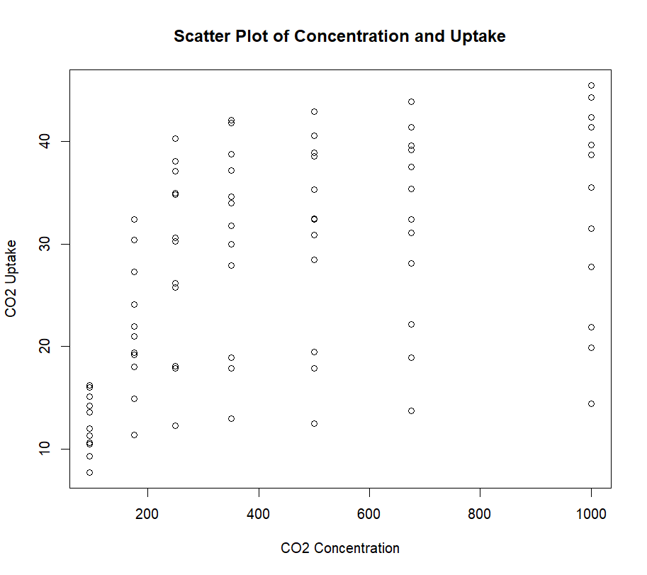
Figure 1: Scatter plot of CO2 concentration and uptake

Result | Number | Student explanation
Correlation r | 0.4851774 | Moderate positive relationship.
Regression equation | uptake = 19.50029 + 0.01773059(conc) | Uptake increases as concentration increases.
Intercept a | 19.50029 | Predicted uptake when concentration is 0.
Slope b | 0.01773059 | For 1 unit more concentration, uptake rises by 0.0177.
p-value of slope | 2.91e-06 | Very small; slope is significant.
Multiple R-squared | 0.2354 | Concentration explains 23.54% of uptake variation.
Adjusted R-squared | 0.2261 | Adjusted explained variation is 22.61%.
Residual standard error | 9.514 | Average prediction error is about 9.514.
F-statistic / p-value | 25.25 / 2.906e-06 | Model is statistically significant.
Sum of error | -2.806644e-13 approx 0 | Total residual error is almost zero.

Student explanation: The correlation value r = 0.4852 is positive, so when concentration increases, uptake usually increases too. It is not very strong because r is not close to 1.
The slope = 0.01773059 is positive and its p-value = 2.91e-06. This means concentration has a statistically significant positive effect on uptake. R-squared = 0.2354, so concentration explains only 23.54% of the change in uptake. Other factors also affect uptake.

Conclusion
- CO2 concentration and uptake have a positive relationship.
- Correlation = 0.4851774, so the relationship is moderate positive.
- Regression equation is uptake = 19.50029 + 0.01773059(concentration).
- Slope is positive and significant, so higher concentration increases predicted uptake.
- R-squared = 0.2354, so concentration explains 23.54% of uptake variation.
- Concentration has high variation: Range = 905, SD = 295.9241, CV = 68.0285%.
- Uptake also varies, but less than concentration: SD = 10.8144, CV = 39.7397%.
- Final result: concentration affects uptake positively, but it is not the only factor.

Appendix A: R Code Used to Generate the Results
This is the R code used to calculate the numbers and create the scatter plot.
rm(list=ls())
data(CO2)
View(CO2)
x = CO2$conc
y = CO2$uptake
n = length(x)
################## Measurement of Central Tendency ##################
AM = mean(x)
GM = (prod(x))^(1/n)
HM = n / sum(1/x)
MED = median(x)
x1 = c(2,4,5,3,8,7,2,5,7,10,2,10,15,10,10)
MOD = names(sort(table(x1), decreasing = TRUE))[1]
Q1 = quantile(x, 0.25)
Q2 = quantile(x, 0.50)
Q3 = quantile(x, 0.75)
Q4 = quantile(x, 1)
D7 = quantile(x, 0.70)
P16 = quantile(x, 0.16)
summary(x)
################## Measurement of Dispersion ##################
Range = max(x) - min(x)
CRange = (max(x) - min(x)) / (max(x) + min(x))
IQR = Q3 - Q1
QD = IQR / 2
CIQR = (Q3 - Q1) / (Q3 + Q1)
################## Mean Deviation ##################
MD = sum(abs(x - AM)) / n
CMD = MD / AM
################## Mean Deviation about Median ##################
MD1 = sum(abs(x - MED)) / n
CMD1 = MD1 / MED
################## Variance, Standard Deviation and CV ##################
V = var(x)
SD = sqrt(V)
CV = SD / AM * 100
SD1 = sqrt(var(y))
CV1 = SD1 / mean(y) * 100
################## Simple Correlation and Regression ##################
plot(x, y,
main = "Scatter Plot of Concentration and Uptake",
xlab = "CO2 Concentration",
ylab = "CO2 Uptake")
cor(x, y)
model = lm(y ~ x)
summary(model)

a1 = coefficients(model)[1]
b1 = coefficients(model)[2]
y.hat = a1 + b1 * x
y.hat
Error = sum(y - y.hat)
### End of Code
-----------------------------------------------------------------------------------------------
-----------------------------------------------------------------------------------------------

> rm(list=ls())
> x=CO2$conc;x
[1] 95 175 250 350 500 675 1000 95 175 250 350 500 675 1000 95 175 250 350 500
[20] 675 1000 95 175 250 350 500 675 1000 95 175 250 350 500 675 1000 95 175 250
[39] 350 500 675 1000 95 175 250 350 500 675 1000 95 175 250 350 500 675 1000 95
[58] 175 250 350 500 675 1000 95 175 250 350 500 675 1000 95 175 250 350 500 675
[77] 1000 95 175 250 350 500 675 1000
> y=CO2$uptake;y
[1] 16.0 30.4 34.8 37.2 35.3 39.2 39.7 13.6 27.3 37.1 41.8 40.6 41.4 44.3 16.2 32.4 40.3 42.1 42.9
[20] 43.9 45.5 14.2 24.1 30.3 34.6 32.5 35.4 38.7 9.3 27.3 35.0 38.8 38.6 37.5 42.4 15.1 21.0 38.1
[39] 34.0 38.9 39.6 41.4 10.6 19.2 26.2 30.0 30.9 32.4 35.5 12.0 22.0 30.6 31.8 32.4 31.1 31.5 11.3
[58] 19.4 25.8 27.9 28.5 28.1 27.8 10.5 14.9 18.1 18.9 19.5 22.2 21.9 7.7 11.4 12.3 13.0 12.5 13.7
[77] 14.4 10.6 18.0 17.9 17.9 17.9 18.9 19.9
> n=length(x);n
[1] 84
> ##################Measurement of Central Tendency#############
> AM=mean(x);AM
[1] 435
> GM=(prod(x))^(1/n);GM
[1] 336.7378
> HM= n/sum(1/x);HM
[1] 253.8142
> MED=median(x);MED
[1] 350
> x1=c(2,4,5,3,8,7,2,5,7,10,2,10,15,10,10)
> a=table(x1);a
x1
2 3 4 5 7 8 10 15
3 1 1 2 2 1 4 1
> b=-a;b
x1
2 3 4 5 7 8 10 15
-3 -1 -1 -2 -2 -1 -4 -1
> c=sort(b);c
x1
10 2 5 7 3 4 8 15
-4 -3 -2 -2 -1 -1 -1 -1
> MOD=names(c)[1];MOD
[1] "10"
> Q1=quantile(x,0.25);Q1
25%
175
> Q2=quantile(x,.50);Q2
50%
350
> Q3=quantile(x,0.75);Q3
75%
675
> Q4=quantile(x,1);Q4
100%
1000
> median(x)
[1] 350
> D7=quantile(x,0.70);D7
70%
500
> P16=quantile(x,0.16);P16
16%
175
> summary(x)
Min. 1st Qu. Median Mean 3rd Qu. Max.
95 175 350 435 675 1000
> Range=max(x)-min(x);Range
[1] 905
> CRange=(max(x)-min(x))/(max(x)+min(x));CRange
[1] 0.826484
> Q3;Q1
75%
675
25%
175
> IQR=Q3-Q1;IQR
75%
500
> QD=IQR/2;QD
75%
250
> CIQR=(Q3-Q1)/(Q3+Q1);CIQR
75%
0.5882353
> MD=sum(abs(x-AM))/n;MD
[1] 248.5714
> CMD=MD/AM;CMD
[1] 0.5714286
> ################ Mean Deviation about median#############
> MD1=sum(abs(x-MED))/n;MD1
[1] 236.4286
> CMD1=MD1/MED;CMD1
[1] 0.6755102
> V=var(x);V
[1] 87571.08
> SD=sqrt(V);SD
[1] 295.9241
> CV=SD/AM*100;CV
[1] 68.02853
> SD1=sqrt(var(y));SD1
[1] 10.81441
> CV1=SD1/mean(y)*100;CV1
[1] 39.73974
> ############################# Simple correlation and Regression############
> plot(x,y)
> cor(x,y)
[1] 0.4851774
> model=lm(y~x);model

Call:
lm(formula = y ~ x)

Coefficients:
(Intercept) x
19.50029 0.01773

> summary(model)

Call:
lm(formula = y ~ x)

Residuals:
Min 1Q Median 3Q Max
-22.831 -7.729 1.483 7.748 16.394

Coefficients:
Estimate Std. Error t value Pr(>|t|)
(Intercept) 19.500290 1.853080 10.523 < 2e-16 ***
x 0.017731 0.003529 5.024 2.91e-06 ***
---
Signif. codes: 0 ‘***’ 0.001 ‘**’ 0.01 ‘*’ 0.05 ‘.’ 0.1 ‘ ’ 1

Residual standard error: 9.514 on 82 degrees of freedom
Multiple R-squared: 0.2354, Adjusted R-squared: 0.2261
F-statistic: 25.25 on 1 and 82 DF, p-value: 2.906e-06

> a1=coefficients(model)[1];a1
(Intercept)
19.50029
> b1=coefficients(model)[2];b1
x
0.01773059
> y.hat=a1+b1*x
> Error=sum(y-y.hat);Error
[1] -2.806644e-13

